How to edit products on the Local Food Coop website

Contents
1 Go to the website 1
2 Select “edit” or “add” product 1
3 Edit product 2
4 Add product 4
4.1 Add product based on existing product 4
5 Add or edit veg and fruit boxes 5
6 Publish product list (make changes live) 6
7 Check product list 6

Summary
Basically, the procedure for editing products before an order cycle opens is as follows:
1) Add/edit individual products
2) Add/edit boxes
3) Publish product list (so it's publicly viewable)
4) Check the published list
5) Repeat steps 1-4 as necessary, up to the time the cycle opens for ordering – e.g. Monday, 12 noon

Go to the website
Click the link below to open the LFC website in your web browser:

http://localhost/foodcoop/shop

Log in using your email address and password.

Select “edit” or “add” product
You should then see your “My Account” page, below.
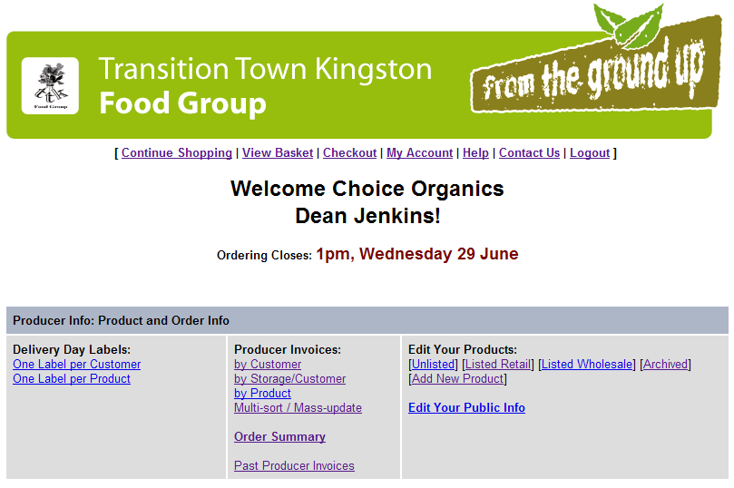
To view and edit existing products (from the last order cycle), click “Listed Retail”, or to add a new product click “Add New Product” (circled above).

N.B. any changes you make to products will not be made “live” (publicly viewable) until you are ready – see the “Publish product list” section below.

Edit product
After clicking on “Listed Retail”, above, you will be presented with a list of products.

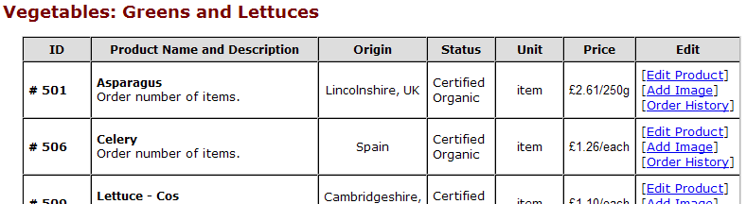

To edit a product, click “Edit Product”, circled above. For example, the price or origin of a product may have changed since the previous order cycle, or the product may no longer be available (in which case you will need to edit it to delist it).

You can also click “Add Image” to add or change the image associated with a product.

Once you click “Edit Product”, you will be presented with a form as below:

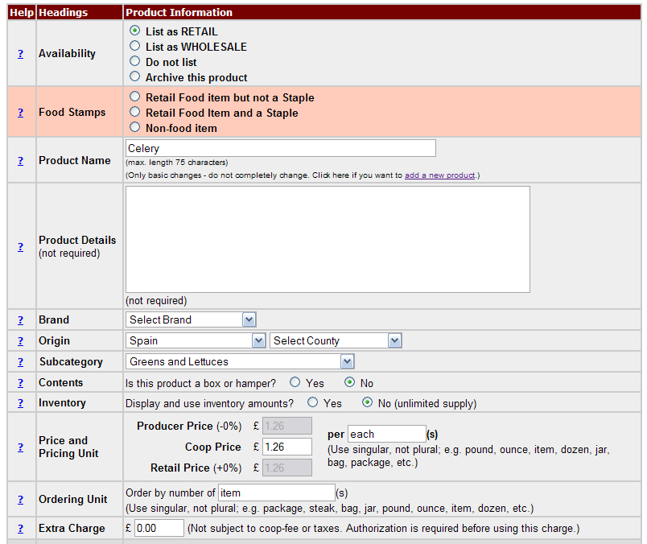

- To delist a product, click “Do not list”, or “Archive this product” (circled above). Either option will cause the product to be removed from the public product listing, once published. I suggest that “Archive this product” is only used if the product is unlikely to appear in future ordering cycles, but functionally it makes little difference which you select. An unlisted or archived product can always be relisted (using “List as RETAIL”) at a future time.
- Product Name and Details are self-explanatory. N.B. Where a product comes in a pack, e.g. cheese or mixed salad bag, I recommend adding the weight under Details.
- A brand can be selected, or added, if required. Click on the “Select Brand” drop-down and click “Add new brand…” at the bottom to add a new brand.
- Country and county of origin can be added, if known.
- A subcategory should be selected.
- A price and unit should be set (circled above). There are two kinds of unit:
  - The Pricing Unit is only displayed to you (the supplier/producer) and admins via the “Product Reference List” (see “How to generate reports on the LFC website”). The Pricing Unit may be “kilo”, “pack” or “item” for example.
  - The Ordering Unit is the smallest quantity of a product that a customer can order. This unit is displayed to the customer on the product list they actually order from. The Ordering Unit may be “half kilo”, “quarter kilo”, “pack or “item” for example. N.B. if Pricing Unit is “kilo” and Ordering Unit is “half kilo” or “quarter kilo”, the system will automatically calculate and display the price per half or quarter kilo to the customer based on the price per kilo you entered. You do not need to do the division yourself.

The bottom of the form is shown below:

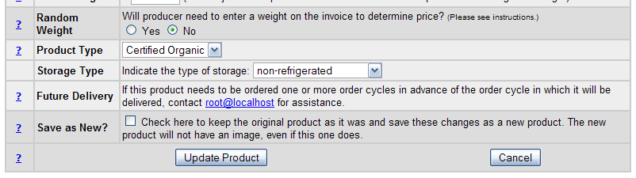
- Product Type can be set (circled above). Typically this will be “Certified Organic”.
- Storage type isn’t much used – the customer doesn’t see this – so don’t worry too much about setting this correctly.

Once you have edited the product information, click the “Update Product” button at the bottom of the form (circled).

Add product
After clicking on “Add new product” from the “My Account” homepage, you will be presented with a form similar to that above.

Fill in the fields as above, and click the “Add Product” button at the bottom of the form.

Add product based on existing product
It is also possible to add a new product by editing an existing product.

Edit a product that is similar to the new product you wish to add, and check “Save as New” (circled below), BEFORE clicking “Update Product”. For example, you may wish to add a new kind of bread that is similar to an existing bread product – using the existing product as a template will make adding the new product simpler and quicker.

Add or edit veg and fruit boxes
Boxes should be edited after all their constituent fruit and veg products have been added or updated. Follow the procedures above to edit or add a new box.

To make a product a box product, select “Yes” to “Is this product a box or hamper?” in the “Contents” row of the form (circled, below).

You will then be able to select the contents of the box, e.g. 2 avocados (circled below):

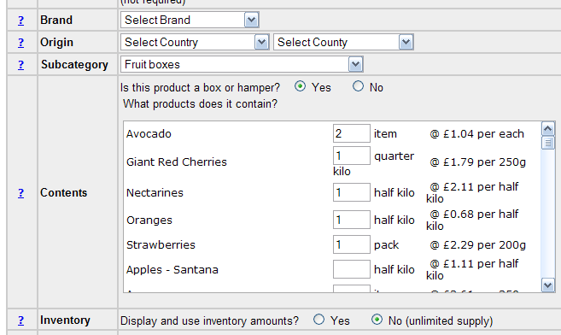

A price for the box will automatically be computed and displayed in the “Price and Pricing Unit” row of the form. You can override this price by typing over it.

Publish product list (make changes live)
To publish the changes you have made to the product list, return to the “My Account” homepage, as below:

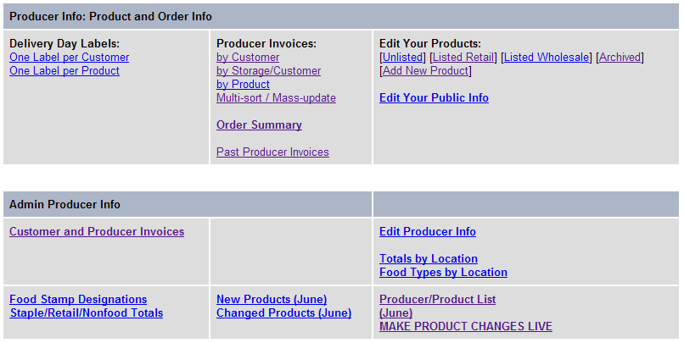

Click the “MAKE PRODUCT CHANGES LIVE” link, circled above. You will then see the following screen. Click the “Click here to make the product list changes live” link, circled below.

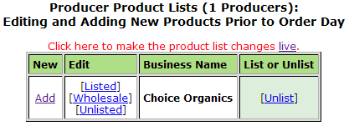

You will see a message confirming that the new product list has been created. You can then log out.

Check product list
Once you have logged out, check that the publicly viewable product lists are correct by following the links circled below on the log in page ( http://localhost/foodcoop/shop ):

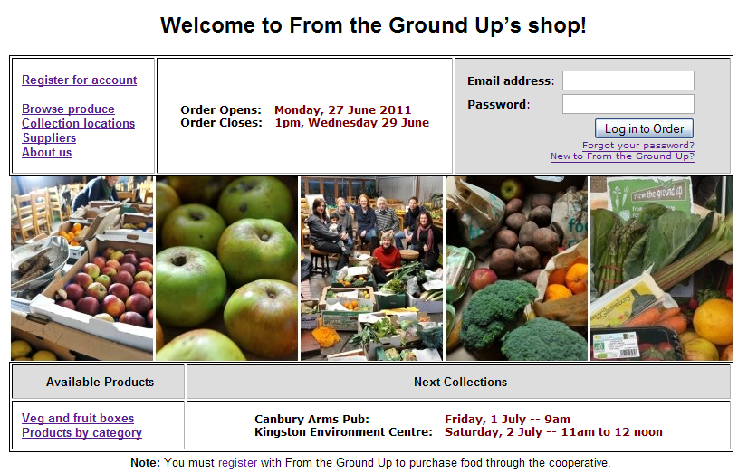

N.B. If you need to make further changes to the product list, log back in, edit the products, and republish the product list as described above. Customers will not be able to order products until the ordering cycle opens at the designated time, e.g. 12 noon Monday, so you can make changes up to then.

